SIGNAL GENERATION AND BASIC SIGNAL OPERATIONS

Experiment 1.1
Generation of Continuous Time Signals
Aim
To verify the generation of a sinusoidal signal with a specific frequency, amplitude, and phase shift using MATLAB. The Aim is to ensure that the signal generator can accurately produce a sinusoidal waveform with the desired parameters.
Apparatus Required
PC with MATLAB.
Program:
% Generation of Continuous Time Signals
clc;
clear;
close all;
% Time axis
t = -5:0.01:5;
% Continuous-time sine signal
x = sin(2*pi*t);
% Plotting
figure;
plot(t, x, 'LineWidth', 2);
grid on;
title('Continuous Time Sine Signal');
xlabel('Time (seconds)');
ylabel('Amplitude');
Output Waveform:
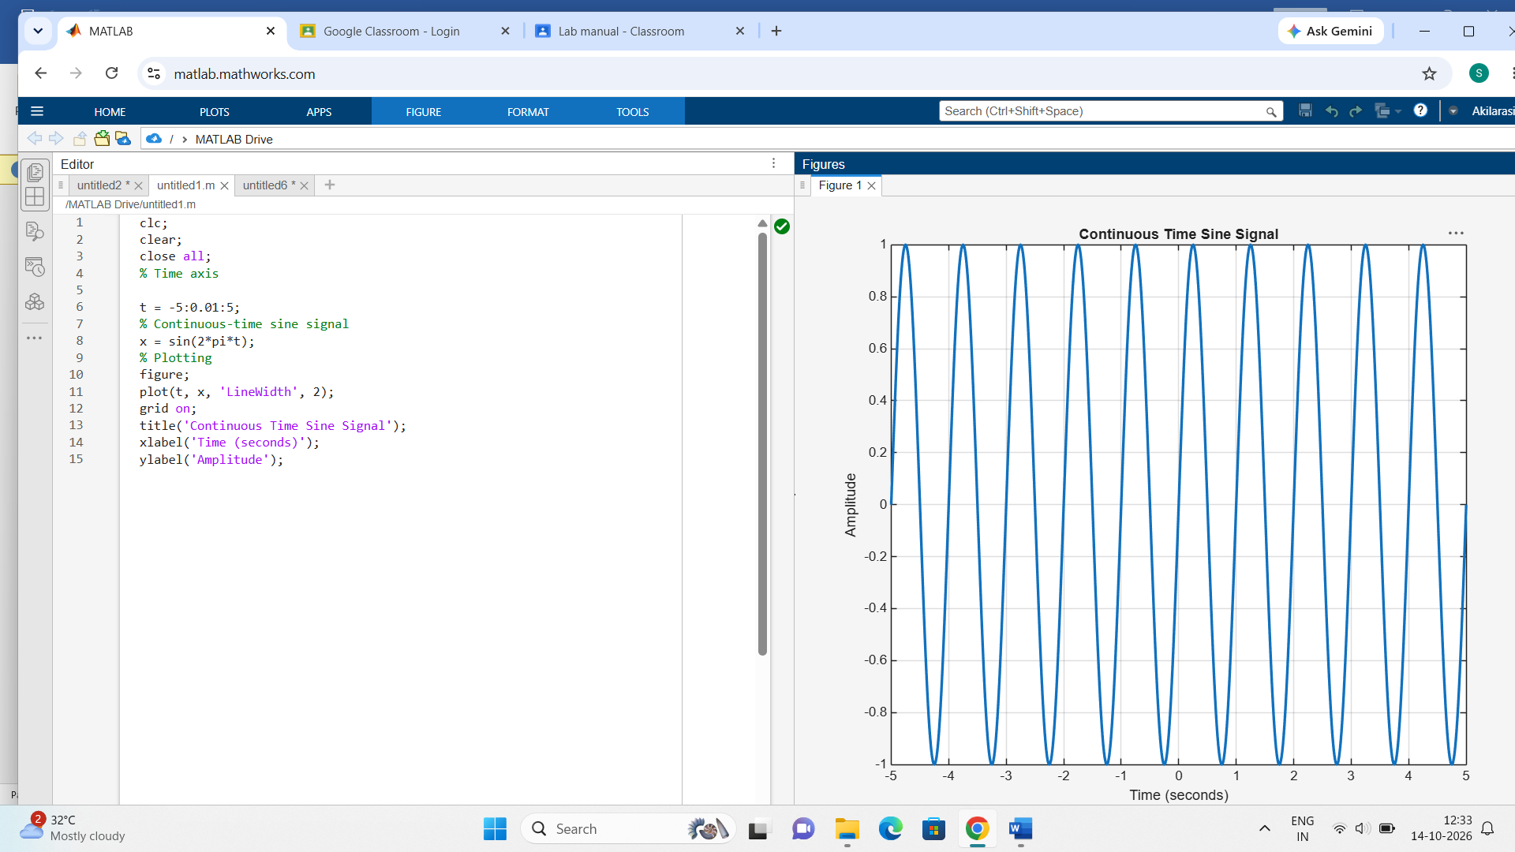

Result:
This test case validates that the signal generator can produce a sinusoidal waveform with the specified frequency, amplitude, and phase shift.

